A

Project Report on

“Online Chatbot based Ticketing System”
Submitted by

Shriyash Amarnath Patil : SOE2022B0306241 Tanmay Dinesh Nagawade : SOE2022B0306278 Narendra Nanasaheb Khamkar : SOE2022B0306213 Suraj Ramdas Pansare : SOE2022B0306234 Vaishnavi Santosh Gopale : SOE2022B0306189 Under the guidance of
Dr. Sofiya Mujawar
In partial fulfillment of the requirements for the degree of Bachelor of Technology in Information Technology of D. Y. Patil University.


DEPARTMENT OF INFORMATION TECHNOLOGY

Academic Year 2024-2025


DEPARTMENT OF INFORMATION TECHNOLOGY

Academic Year 2024-2025

CERTIFICATE

This is to certify that the project entitled “Online Chatbot based Ticketing System” is a record of bonafide work carried out by Shriyash Patil, Tanmay Nagawade, Narendra Khamkar, Suraj Pansare, Vaishnavi Gopale under my supervision and guidance, in partial fulfillment of the requirements for the award of Degree of Bachelor of Technology in Information Technology from D. Y. Patil University for the year 2024-25.

Dr. Sofiya Mujawar Dr. Moresh Mukhedkar
(Guide) (Project Coordinator)

Dr. Vivek Patil
(H.O.D) (External Examiner)

Prof. Dr. Pranav Charkha
(Dean SOET)

ACKNOWLEDGEMENT

I would like to express my sincere gratitude to all those who contributed to the successful completion of this project on an online chatbot-based ticketing system.
Firstly, I extend my heartfelt thanks to Dr. Sofia Mujawar, whose guidance and encouragement were instrumental throughout the project. Your expertise and insights helped shape this project into its final form.
I would also like to acknowledge the support of D. Y. Patil University for providing the resources and environment necessary to carry out this project. Special thanks to the Department of Information Technology for their continuous support and feedback, which greatly enriched the quality of the work.

INDEX
- Abstract
- Preface
- List of Figures

Chapter No. | Title | Page No.
Chapter No. 1 | Introduction | 7
Chapter No. 2 | Literature Survey | 8,9
Chapter No. 3 | Proposed System | 10
Chapter No. 4 | Methodology | 11
Chapter No. 5 | Schematic | 12
Chapter No. 6 | Flowchart/Algorithm | 13
Chapter No. 7 | Applications | 14,15
Chapter No. 8 | Conclusions | 16
 | Bibliography | 17
 | Appendix | 18

ABSTRACT

The increasing demand for efficient and automated customer support has led to the development of chatbot-based ticketing systems. This project presents an online chatbot-based ticketing system designed to streamline customer service operations by automating the ticket creation and resolution process. The system integrates a conversational AI chatbot capable of handling common customer queries, creating support tickets for unresolved issues, and guiding users through troubleshooting steps in real-time.
The chatbot utilizes natural language processing (NLP) to understand user queries, enabling it to offer personalized responses and initiate ticket generation when necessary. The system is designed to integrate seamlessly with existing customer support platforms, allowing for efficient issue tracking, prioritization, and resolution. This automation not only reduces the workload on human agents but also enhances response time and customer satisfaction.

PREFACE

The growing reliance on digital platforms for customer service has brought forth the need for more efficient, scalable, and responsive solutions. In today's fast-paced world, businesses are expected to provide quick and effective support to their customers, often requiring round-the-clock availability. The online chatbot-based ticketing system presented in this project is a response to these evolving needs, aiming to enhance customer service experiences while reducing the operational burden on human support teams.
This project leverages advancements in artificial intelligence, particularly natural language processing (NLP), to develop an intelligent chatbot capable of addressing customer inquiries, providing real-time assistance, and generating support tickets for unresolved issues. The system is designed with flexibility in mind, making it adaptable for integration with various customer support platforms and suitable for a range of industries.
The journey of creating this system involved exploring the latest technologies in AI, understanding customer service workflows, and addressing challenges such as maintaining conversational context and ensuring accurate ticket generation. It also offered an opportunity to reflect on how AI can positively transform customer interactions and improve organizational efficiency.
Through this project, I hope to contribute to the growing trend of AI-driven customer service solutions and demonstrate the potential of chatbot systems in enhancing customer satisfaction. This preface serves as an introduction to the motivations, challenges, and goals that shaped the development of this online chatbot-based ticketing system.

Chapter 1 Introduction

In today’s fast-paced world, customer support efficiency is paramount. Our Chatbot-Based Ticketing System offers an innovative solution to streamline customer inquiries and support requests. By integrating AI-powered chat technology, users can submit tickets, receive updates, and resolve issues faster, all within a conversational interface. An online chatbot-based ticketing system is an automated solution designed to streamline customer service and support. It uses AI-driven chatbots to handle customer inquiries, process ticket submissions, and provide instant responses to common issues. By automating these processes, the system reduces response times, enhances user experience, and allows support teams to focus on more complex tasks. The chatbot can assist with creating, tracking, and managing support tickets, ensuring that requests are routed to the right department or agent efficiently. This modern approach improves overall productivity while maintaining a high standard of customer satisfaction. An online chatbot-based ticketing system is a digital tool that utilizes AI powered chatbots to automate and manage customer support services. It allows users to interact with a virtual assistant to submit inquiries or report issues, which are then converted into support tickets. The system can efficiently handle tasks such as categorizing, prioritizing, and assigning tickets to the appropriate teams or agents. By providing instant responses, offering self- service options, and automating routine queries, it improves the efficiency of customer service operations. This approach reduces human effort, minimizes delays, and enhances the overall customer experience by offering 24/7 availability and consistent support.

Chapter 2 Literature Survey
S.No | Paper Title & Authors | Methodology | Key Contributions | Limitations | Year
1. | A Survey on Chatbot Implementation in Customer Support Systems | Literature review of chatbot architectures for customer support. Comparison of frameworks like Dialogflow and Rasa. | Provides a high- level overview of chatbot architecture for automating ticket creation and management in customer support systems. | Lacks detailed implementation and real-world application data. | 2020
2. | Automating IT Support Ticket Categorization with Machine Learning | Machine learning-based ticket classification  using NLP. Focus on supervised learning models for IT support ticket categorization. | Demonstrates the use of NLP for classifying and routing support tickets, improving efficiency in ticket handling. | No focus on the chatbot interface or user interaction model. Limited to ticket classification. | 2019
3. | End-to-End Framework for Building Conversational Agents for Customer Support | Developed an end-to-end architecture for conversational agents with an integration model for customer support systems. | Provides a complete framework from chatbot design to deployment, with a focus on real- time ticket handling. | Primarily focused on architecture without extensive performance benchmarks. | 2021

4. | Chatbots in Business Processes: A Case Study on Ticketing Systems | Case study methodology exploring the integration of chatbots into ticketing systems and other business processes. | Detailed insights on how chatbots can improve efficiency in ticket handling and customer interaction processes. | Based on a single case study, so generalizability to other industries may be limited. | 2020
5. | Leveraging AI Chatbots for IT Help Desk Automation: A Case Study | AI-driven chatbot implementation for automating help desk functions, including ticket generation and query resolution. | Proposes AI chatbot solutions that reduce human intervention in help desk ticketing systems and automate ticket lifecycle processes. | Focuses on IT- specific help desk automation without generalization to other support systems. | 2019
6. | Usability of Conversational Agents for IT Ticketing Systems | Usability testing of chatbots in IT ticketing systems, focusing on user experience and performance. | Highlights user experience challenges in using chatbots for IT ticketing and suggests improvements for user satisfaction. | Limited scope of chatbot functions— focused mainly on usability rather than full integration with ticketing systems. | 2020

Chapter 3 Proposed System

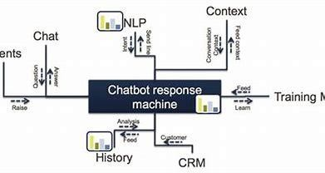

Chapter 4 Methodology:

The methodology for developing an online chatbot-based ticketing system involves several key steps. First, requirements gathering is conducted to understand the specific needs of users and the organization, such as the types of issues commonly addressed and preferred ticket management workflows. Next, chatbot design and development take place, leveraging natural language processing (NLP) to enable the bot to understand user queries and guide them through the ticketing process. Integration with an existing ticket management system or CRM is crucial to automate ticket creation, assignment, and tracking

Chapter 5 Schematic

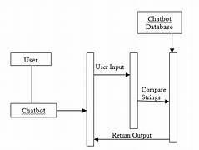

Chapter 6
Flowchart and Algorithm

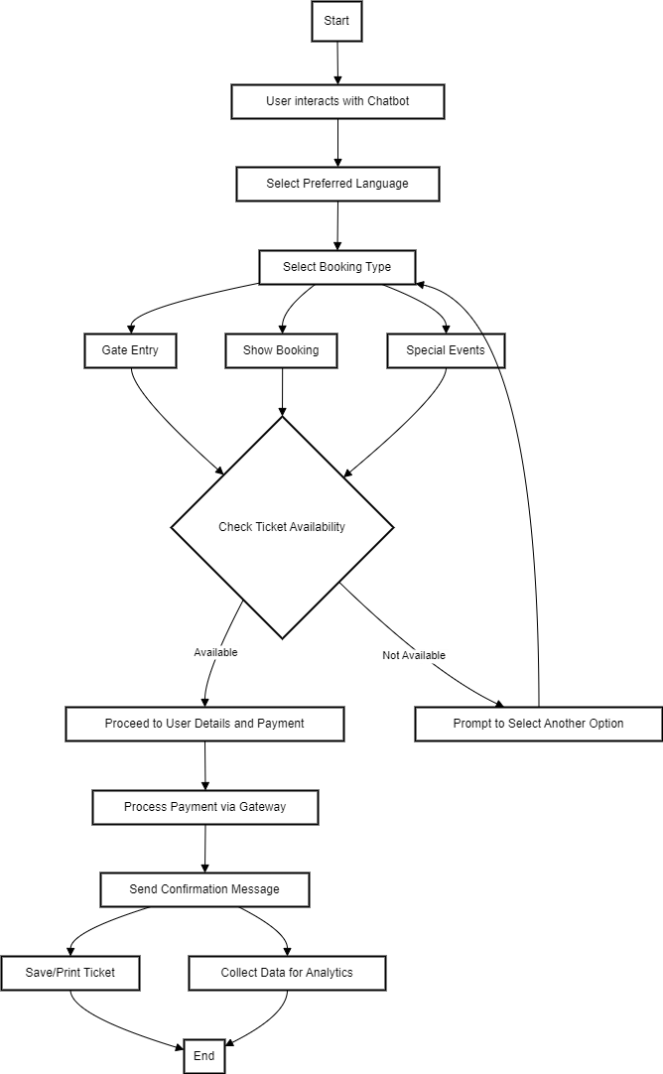

Chapter 7
Application, Advantages and Disadvantages

Application of an Online Chatbot-Based Ticketing System:
- Customer Support: Handling queries, raising tickets for unresolved issues, and providing real-time assistance.
- IT Helpdesk: Automating technical support requests, allowing users to report IT issues and track resolutions.
- E-commerce Support: Managing order inquiries, returns, and refunds, as well as providing product information.
- HR Systems: Assisting employees with HR-related queries, like leave applications, policy clarifications, and payroll issues.
- Event Management: Allowing users to book tickets, check availability, and receive confirmation via chatbots.

Advantages of a Chatbot-Based Ticketing System:

- 24/7 Availability: Chatbots provide round-the-clock service, offering support and resolving common issues without human intervention.
- Faster Response Time: They can instantly respond to user queries, speeding up the ticketing process and improving user experience.
- Cost Efficiency: Reduces the need for a large support team, cutting down on operational costs.
- Scalability: Chatbots can handle a large volume of requests simultaneously, making them ideal for growing businesses.
- Automation and Efficiency: Automated ticket creation and categorization help in faster issue resolution and effective workload management.

- Consistency: Ensures that responses are uniform and accurate, reducing the risk of human error.
- Multilingual Support: Chatbots can be programmed to handle multiple languages, making them accessible to a global audience.
Disadvantages of a Chatbot-Based Ticketing System:

- Limited Understanding: Chatbots may struggle with complex queries or understanding context, leading to incorrect responses.
- Lack of Human Touch: Some customers may prefer speaking with a human, especially for emotionally sensitive or complex issues.
- Dependence on Predefined Rules: Chatbots work on predefined rules or AI models, which can limit their ability to handle unexpected scenarios.
- Initial Setup Cost and Maintenance: Implementing an advanced chatbot system may require significant investment and ongoing maintenance to update and improve its functionality.
- Language and Tone Limitations: While chatbots can handle multiple languages, understanding different dialects, slang, or tone of conversation may be a challenge.
- Escalation Problems: If the chatbot fails to resolve an issue, it might not escalate the case efficiently, leading to delays in human intervention.

Chapter 8 Conclusion

An online chatbot-based ticketing system offers significant benefits in terms of efficiency, cost savings, and 24/7 availability, making it a valuable tool for businesses looking to enhance their customer support and service operations. By automating repetitive tasks and handling common queries, it allows human agents to focus on more complex issues. However, limitations such as difficulty in understanding complex queries and the lack of a human touch must be addressed through thoughtful design and proper escalation protocols. When implemented effectively, it can greatly improve user experience and operational efficiency.

Bibliography

Chatbot Frameworks and Architecture:
Paper Title: "A Survey on Chatbot Implementation in Customer Support Systems"
Authors: Abdellatif El Meslouhi, Mohamed Khamlichi, Mohamed Abderrahim.

Natural Language Processing (NLP) for Ticket Classification:
Paper Title: "Automating IT Support Ticket Categorization with Machine Learning"
Authors: Chirag Patel, Rakesh Sharma, and Seema Shah.

End-to-End Chatbot Design for Customer Service:
Paper Title: "End-to-End Framework for Building Conversational Agents for Customer Support"
Authors: Karthik Ramesh, Nikhil Choudhary.

Integration of Chatbots in Business Processes:
Paper Title: "Chatbots in Business Processes: A Case Study on Ticketing Systems"
Authors: Marco Pichler, Josef Dorn, and Astrid Böhm.

